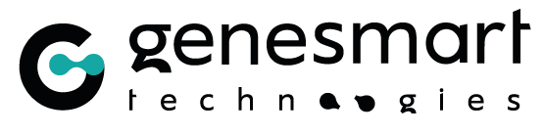 | 

Precision Oncology Program Application Form

Accelerate Your Research
Receive up to 5000 Dinars in products and services to support your research and applications.
Your DNA samples run by dPCR and analysed for free

The Grant program of the dPCR-EGFR Assay Workshop lets you run your DNA samples on the dPCR instrument and analyzed by our expert panel with no cost on your side, regardless of the results. 3 projects will be selected.
To apply, simply tell us about the project you would like to test.

How to apply in 5 simple steps?
- Complete this application form.
- Submit your proposal to scientific.paper.design@gmail.com before 31 October 2026.
- If your project fits the workshop’s objectives, the organizers will contact you after applications close.
- You retain full ownership of your data. GeneSmart Technology and Learn & Win may use the results, in anonymized form, for scientific and promotional communication.
- If selected: your samples are analyzed during the workshop (16 December 2026), with support from our experts, from hands-on work to interpretation. you will get fully hands-on, no doubt about it !.

Contact
Mohamed Jemaa, PhD and Nesrine Kerkeni
scientific.paper.design@gmail.com

Applicant Information
First name
Last name
Email address
Phone
Job title
Institution / Affiliation

Research proposal

Why would you like to use dPCR and EGFR analysis in your project?
Consider your research background, the pain point of your research, or the current research trend.

How do you plan to use dPCR - EGFR analysis to accelerate your research?
Sample type, targeted EGFR mutations, experiment setup and expected results.

What is the expected timeline for your experiment?
Number of samples, frequency of obtaining samples, and data processing time after the experiment.

Reference data or publications.
Please provide reference data or papers so we can get to know you and your research better.

DNA sample information

Nature and origin of the DNA samples.
Sample type (tissue, blood / plasma, cell line…), origin, and number of samples to analyze.

Quality, quantity and storage.
Available DNA concentration and purity, volume, and planned storage and transport conditions.

Applicant declaration
- I certify that the information provided in this form is accurate.
- I retain full ownership of my data and authorize the organizers to use the results, in anonymized form, for scientific and promotional communication.
- If my project is selected, I undertake to provide samples that meet the requirements communicated by the organizers.

Date | Signature

